Extraction data from SDC.

We followed the following steps and filter to construct the sample of US IPOs between 1970 and 2015.

1. Pulling data from SDC:
   1. Select “Common Stock” in “Global New Issues Database” (Figure 1)
   2. Select dates between 01/01/1970 and 12/31/2015 (Figure 2)
   3. Select USA and Nation Code (Figure 3 and Figure 4)
   4. These filters result in 40,524 observations (Figure 5)
   5. Extract the following variables in SDC request (Figure 6 and attached report)

Filing date, Issue date, Issuer, State, Nation, Offer price, Security, Description, REIT, Unit, Depositary, Deal number, Closed-End Fund, CUSIP, CUSIP9, Proceeds, Issue Priced wrt range, VC, Gross spread, Manager codes, Tech industry

1. Cleaning
   1. Exclude certain types of securities:
      1. "Units", "Ltd Prtnr Int", "MLP-Common Shs", "Shs Benficl Int", "Ltd Liab Int", "Stock Unit", "Trust Units", "Beneficial Ints"
      2. Limits sample to 37,692 observation
   2. Exclude
      1. REIT (by REIT variable), Units (by Unit variable), ADR (by Depositary variable), CEF (by Closed-End Fund variable) and with offer price below $5.0
   3. Use CUSIP9 (if avaliable) and CUSIP to match IPO sample with CRSP
      1. Exclude observation if they do not appear on CRSP within a week.
      2. Final sample 9,145 obervations

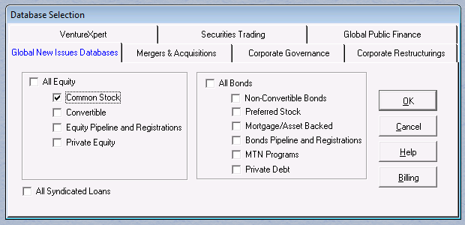

Figure

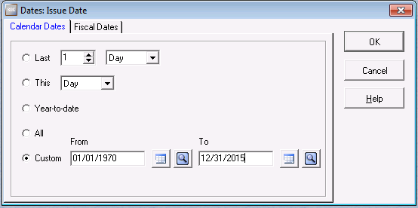

Figure

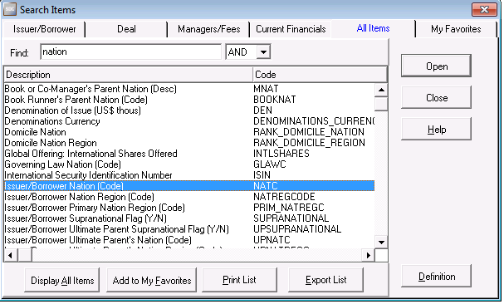

Figure

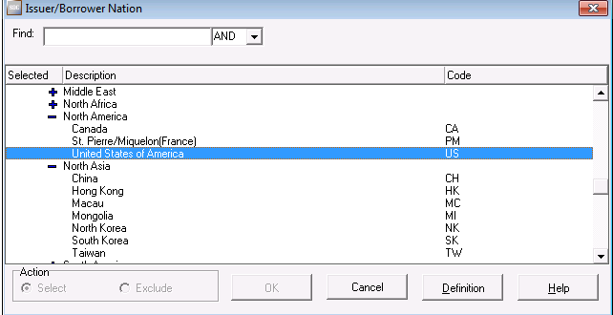

Figure

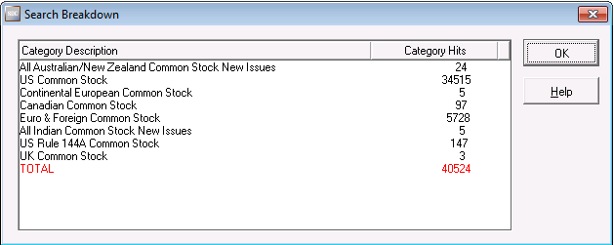

Figure

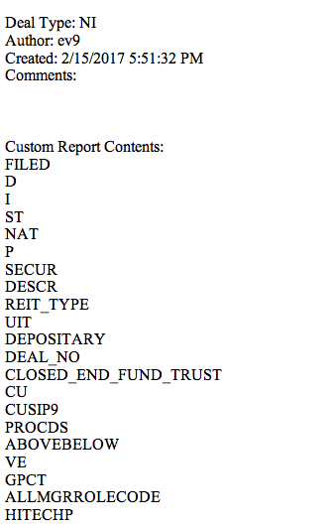

Figure SDC report